Vocabulary Term | Definition | Picture or Symbol
Discrete Data | Data whose possible values are countable and often finite. | 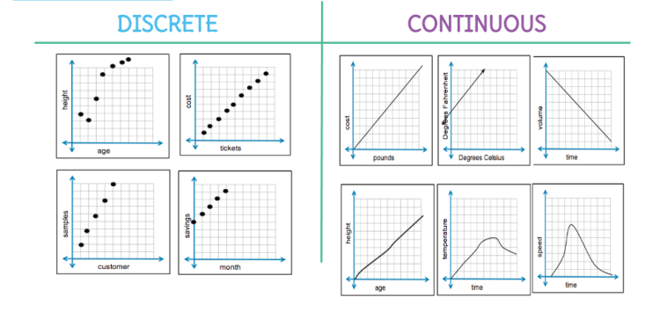
Continuous Data | Data which can take any numerical value within a range.
Sample | A subset of data selected from a population. | 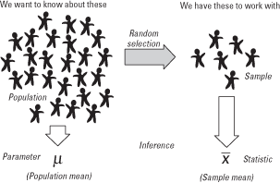
Population | Represents all the possible data that are of interest in a study or survey.
Normal Curve | A bell-shaped curve that is symmetric about the mean of the data.  A normal curve models a theoretical data set that is said to have a normal distribution. | 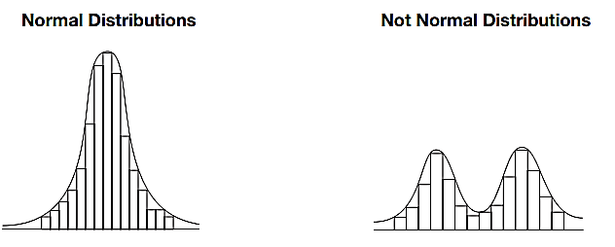
Mean | The average. | The mean of a population is represented with the symbol $σ$.  The mean of a sample is represented with the symbol $\overline{x}$
Standard Deviation | A measure of how spread out the  data are from the mean. | • A lower standard deviation represents data that are more tightly clustered near the mean.  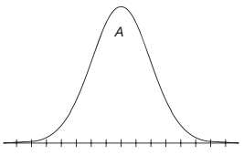  • A higher standard deviation represents data that are more spread out from the mean.  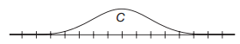
Shape | Symmetric, skewed right, skewed left | 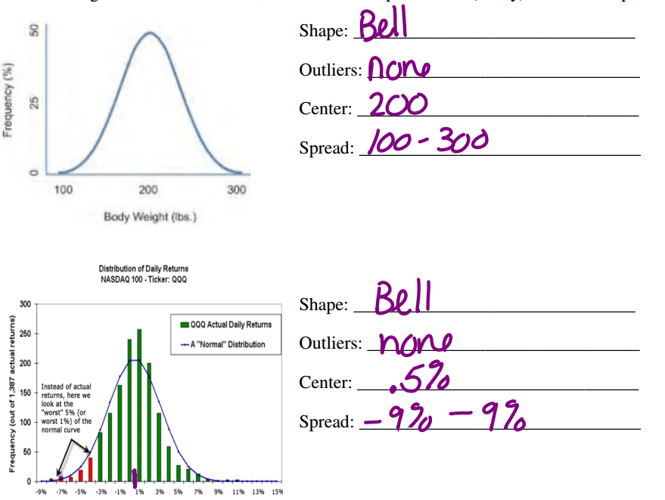
Outlier | A data point that is distinctly separate from the rest of the data.
Center | The mean of the set of data.
Spread | How spread out or compact a distribution is.
Standard Normal Distribution | A normal distribution with a mean value of 0 and a standard deviation of 1$σ$ or 1s. | 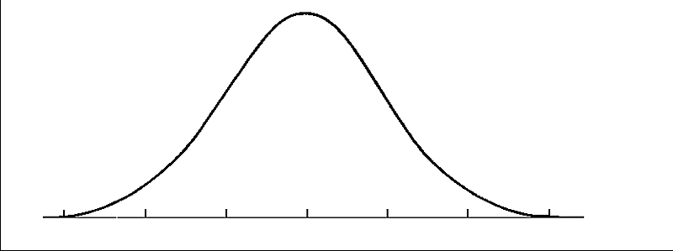
Empirical Rule for Normal Distributions | Approximately 68% of the data in a normal  distribution for a population is within 1 standard deviation of the mean.  Approximately 95% of the data in a normal distribution for a population is within  2 standard deviations of the mean.  Approximately 99 .7% of the data in a normal distribution for a population is within 3 standard deviations of the mean. | 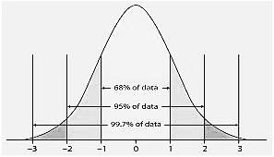
z-score | A number that describes a specific data value’s distance from the mean in terms of standard deviation units. | $$z=\frac{X-μ}{σ}$$
Probability | The chance of something happening. | $$\frac{\# of favorable outcomes}{Total \# of outcomes}$$

