**IM3-Semester 2 Final Exam Review**

**Chapter 1**

1. A normal distribution is classified as:
   1. Neither a bell-shaped nor symmetrical curve
   2. A bell-shaped curve but not symmetrical curve
   3. A bell-shaped and symmetric curve
   4. A Skewed curve
2. Given the normal curve identify the mean and standard deviation

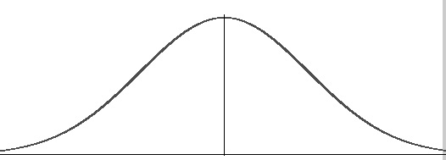

* 1. Mean of 15.6, standard deviation of 3.6
  2. Mean of 15.6, standard deviation of 1.8
  3. Mean of 10.2, standard deviation of 3.6
  4. Mean is 21, standard deviation of 1.8

10.2 12 13.8 15.6 17.4 19.2 21

1. The Emperical Rule for normal distribution states the percent of data the is below the mean is:
   1. 95%
   2. 64%
   3. 50%
   4. 32%
2. The Emperical Rule for normal distribution states the percent of data that is between two (2) standard deviations of the mean is:
   1. 99.7%
   2. 95%
   3. 64%
   4. 50%
3. Calculate the z-score for the problem below:

The percent of adult women shorter than 71 inches tall, given the adult women’s

heights are normally distributed and the mean height is 64 inches tall with a

standard deviation of 2.5 inches.

* 1. -2.8
  2. 2.8
  3. 54
  4. 1.1

1. If a z-score for a particular data point has a z-score of -.93 find the percent of data below the data point. A z-table is provided below:

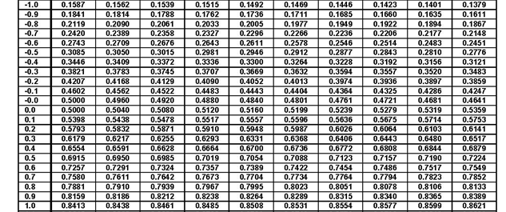

* 1. 16.11%
  2. 17.62%
  3. 34.83%
  4. 82.38%

1. Determine the 80th percentile of ACT scores, given that the ACT scores are normally distributed and the mean is 20.8 and a standard deviation of 4.8.
   1. A score of 25
   2. A score of 14
   3. A score of 29
   4. A score of 20

**Chapter 8**

1. Write the explicit (*n*th term) rule for the sequence 13, 10, 7, 4, 1, …
2. 
3. 
4. 
5. 

1. Write the explicit (*n*th term) rule for the sequence 4, 12, 36, 108, …
2. 
3. 
4. 
5. 
6. How many terms are in the following sequence? 4, 13, 22, 31, …, 130
7. 5
8. 15
9. 13
10. 14
11. How many terms are in the following sequence? 25, 50, 100, 200, … 6400
12. 256
13. 255
14. 9
15. 10
16. Find the sum of the infinite series, if it exists: 

1. No sum
2. 130
$85\frac{1}{3}$

$65$

4. Find the sum of the infinite series, if it exists: 

1. 121
2. 120
3. 168
4. No sum
5. Which of the following series will **not** have a sum?
6. 
7. 
8. 
9. 
10. An auditorium has 10 seats in the 1st row, 14 seats in the second row, 18 seats in the 3rd row and so on. How many total seats are in the auditorium if there are 20 rows in the auditorium?

1. 62 seats
2. 960 seats
3. 640 seats
4. 990 seats

|  |  |
| --- | --- |
| Time  (years) | Joe’s  Salalry ($) |
| 1 | 45,000 |
| 2 | 45,900 |
| 3 | 46,818 |
| 4 | 47,754 |
| 5 | 48,709 |

1. The table below shows Joe’s salary for the first five years of his new job. His boss guarantee to continue the same rate of increase in his salary for as long as he works at the company.

What will his salary be in the 25th year?

1. $49,927
2. $96,727
3. $73,827
4. $72,380
5. Determine if the sequence $-8, 2, 12, 22, 32, 42, …$ is geometric or arithmetic and then find either the common difference or common ratio.
6. Arithmetic; $d=10$
7. Arithmetic; $d=6$
8. Geometric; $r= -0.25$
9. Geometric; $r=4$

**Chapter 12**

1. Decide if the function $f\left(x\right)={\left(3\right)}^{x}$ is exponential growth or decay. Then, describe its end behavior using limits.
2. Exponential growth; $\lim_{x→ -∞}{f\left(x\right)=∞, } \lim_{x→ ∞}{f\left(x\right)=0 }$
3. Exponential decay; $\lim_{x→ -∞}{f\left(x\right)=∞, } \lim_{x→ ∞}{f\left(x\right)=0 }$
4. Exponential growth; $\lim_{x→ -∞}{f\left(x\right)=0, } \lim_{x→ ∞}{f\left(x\right)=∞ }$
5. Exponential decay; $\lim_{x→ -∞}{f\left(x\right)=0, } \lim_{x→ ∞}{f\left(x\right)=∞ }$
6. Decide if the function $f\left(x\right)={\left(2\right)}^{-x}$ is exponential growth or decay. Then, describe its end behavior using limits.

a. Exponential growth; $\lim_{x→ -∞}{f\left(x\right)=∞, } \lim_{x→ ∞}{f\left(x\right)=0 }$

b. Exponential decay; $\lim_{x→ -∞}{f\left(x\right)=∞, } \lim_{x→ ∞}{f\left(x\right)=0 }$

c. Exponential growth; $\lim_{x→ -∞}{f\left(x\right)=0, } \lim_{x→ ∞}{f\left(x\right)=∞ }$

d. Exponential decay; $\lim_{x→ -∞}{f\left(x\right)=0, } \lim_{x→ ∞}{f\left(x\right)=∞ }$

1. Which describes the asymptotic behavior of the function ?

4. Determine the function that corresponds to the given graph.

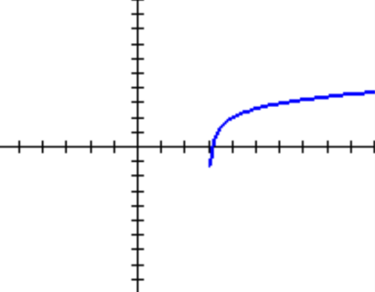

1. *f(x)= log3(x + 3) + 2*
2. *f(x)= log3(x + 3) – 2*
3. *f(x)= log3(x – 3) + 2*
4. *f(x)= log3(x – 3) – 2*

*The asymptote is .*

5. Which describes the transformation of the graph of $f\left(x\right)=5^{x}$ to create the graph of

$g\left(x\right)={-5}^{x}+2$?

1. Reflection over y-axis, down 2 units
2. Reflection over y-axis, up 2 units
3. Reflection over x-axis, down 2 units
4. Reflection over x-axis, up 2 units

6. Which describes the transformation of the graph of $f\left(x\right)=log(x)$ to create the graph of

$g\left(x\right)=log\left(x-2\right)+4$?

a. Right 2 units, down 4 units

b. Right 2 units, up 4 units

c. Left 2 units, down 4 units

d. Left 2 units, up 4 units

7. Given the function: $h\left(x\right)=-log\left(x+5\right)-4,$ write the equation of the vertical asymptote.

a. x = 5

b. x = -5

c. x = 4

d. x = -4

1. Which function is reflected over the x-axis and translated one unit down of the function

?

9. Which describes the function $f\left(x\right)=\log\left(x-3\right)+5?$

1. The function is increasing over $(3, ∞)$.
2. The function is increasing over $\left(0, ∞\right).$
3. The function is decreasing over $\left(3, ∞\right).$
4. The function is decreasing over

10. Which describes the function *f(x) = 5x + 2?*

1. There is a vertical asymptote at x = 2
2. There is a horizontal asymptote at y = 2
3. The range of the function is (- $∞, ∞)$
4. The domain of the function is $\left(0, ∞\right)$
5. The domain of the function *f(x) = 3x* is (- $∞, ∞)$. What MUST be true of the inverse function

${f^{-1}=log}_{3}(x)$?

a. The inverse is decreasing on the interval (- $∞, ∞).$

b. The domain of the inverse is also (- $∞, ∞).$

c. The range of the inverse is (- $∞, ∞).$

d. The inverse is increasing on the interval (-

12. What is a **true** statement about all logarithmic functions of the form *f(x) = loga(x)?*

1. The domain of $f(x)$ is $(-∞, ∞)$.
2. The domain of $f(x)$ is $(-∞, 0)$.
3. The range of $f(x)$ is $(-∞, ∞)$.
4. The range of is .

13. What is a **true** statement about all exponential functions of the form *f(x) = ax*?

1. The domain of $f(x)$ is $(-∞, 0)$.
2. The domain of $f(x)$ is $(0, ∞)$.
3. The range of $f(x)$ is $(-∞, 0)$.
4. The range of is .

14. The graph of an exponential function is given. Which of the following is the correct equation of the function?

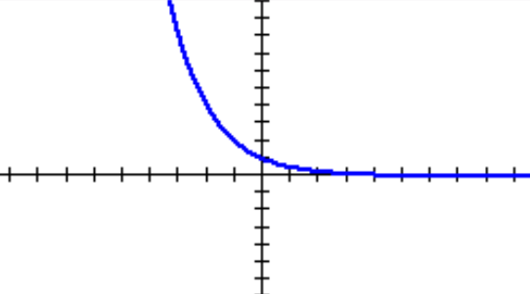



15. If is translated up 4 units, what is the equation of the asymptote, if it exists?

$x=4$

$y=4$

$y=1$

4. No asymptote

16. The population of a Orland Park in 2015 was 56,085. It is projected that the population will increase at a rate of 1.9% each year moving forward. Which function describes the population as a function of the number of years, t, since 2015? Use the formula .



17. The number of rodents in a Chicago neighborhood increases according to the function $B=1800e^{0.04t}$, where *t* is measured in years. How many rodents will be in this neighborhood after 8 years?

1. 1,307
2. 1,566
3. 2,479
4. 44,159

18. Kobe deposits $1,500 in a savings account that earns 3% interest compounded monthly. How much money is in his account at the end of 8 years? Use the formula $A=P{\left(1+\frac{r}{n}\right)}^{nt}.$

1. $1,530.26
2. $1,545.62
3. $1,900.15
4. $1,906.30

**Chapter 13**

1. Convert the equation $2^{x}=16$ from exponential to logarithmic form.
2. $\log_{16}{2}=x$ b. $\log_{x}{2}=16$ c. $\log_{2}{16}=x$ d. $\log_{x}{16}=2$
3. Convert the equation $\log_{3}{27=x}$ from logarithmic to exponential form.
4. $x^{3}=27$ b. $3^{27}=x$ c. $3^{x}=27$ d. $x^{27}=3$
5. Solve the logarithmic equation $\log_{5}{x}=2$.
6. $x=25$ b. $x=10$ c. $x=32$ d. $x=1$
7. Solve the exponential equation ${\left(\frac{1}{2}\right)}^{x}=64$.
8. $x=-5$ b. $x=-4$ c. $x=-6$ d. $x=6$
9. Condense the logarithm ${4log}_{2}{x}-\log_{2}{7}$ using properties of logarithms.
10. $\log_{2}\left(\frac{x^{4}}{7}\right)$ b. $\log_{2}\left(\frac{4x}{7}\right)$ c. $\log_{2}\left(28x\right)$ d. $\log_{2}{(x^{4}-7)}$
11. Expand the logarithm $\ln{\frac{4x}{5}}$ using properties of logarithms.
12. $\ln{4x}-\ln{5}$ b. $\ln{4}-\ln{x}-\ln{5}$ c . $\ln{4}+\ln{x}-\ln{5}$ d. $\ln{x^{4}-\ln{5}}$
13. Which is the only solution of the equation $2^{x-3}=32$?
14. $x=5$ b. $x=2$ c. $x=9.4$ d. $x=8$
15. Solve the equation $\log_{4}\left(x^{2}-4x+5\right)=0$ and check for extraneous solutions.
16. $x=2$ b. $x=-2$ c. $x=4$ d. $x=0$

1. Solve the exponential equation $2{(4)}^{x+1}-3=9.$
2. $x=0.29$ b. $x=-0.29$ c. $x=0.5$ d. $x=-0.21$
3. Which are all solutions of the equation $\log_{2}{16x}-\log_{2}{4}=3?$
4. $x=2, x=-2$ b. $x=2$ c. $x=3$ d. $x=-3$